NYC’S BEE TRUE TO YOU
AN ORIGINAL POP/ROCK ANTI-BULLYING/SOCIAL EMOTIONAL MUSICAL
(TYPICALLY PERFORMED IN SCHOOLS)
IS PLEASED TO ANNOUNCE A NEW DIGITAL LEARNING PLATFORM

BRINGING THEATRE, DANCE PARTIES, WORKSHOPS, PRIVATE MUSIC LESSONS AND MORE TO FAMILIES, TEACHERS AND EDUCATORS VIA ZOOM...
PERFECT FOR SUMMER CAMPS!

PODCAST VIDEO SERIES: BUZZ SOCIAL
LIVE FACEBOOK PREMIERE ON SATURDAY, MAY 30TH AT 1PM EST

DEBUT SELF-TITLED ALBUM OUT NOW!

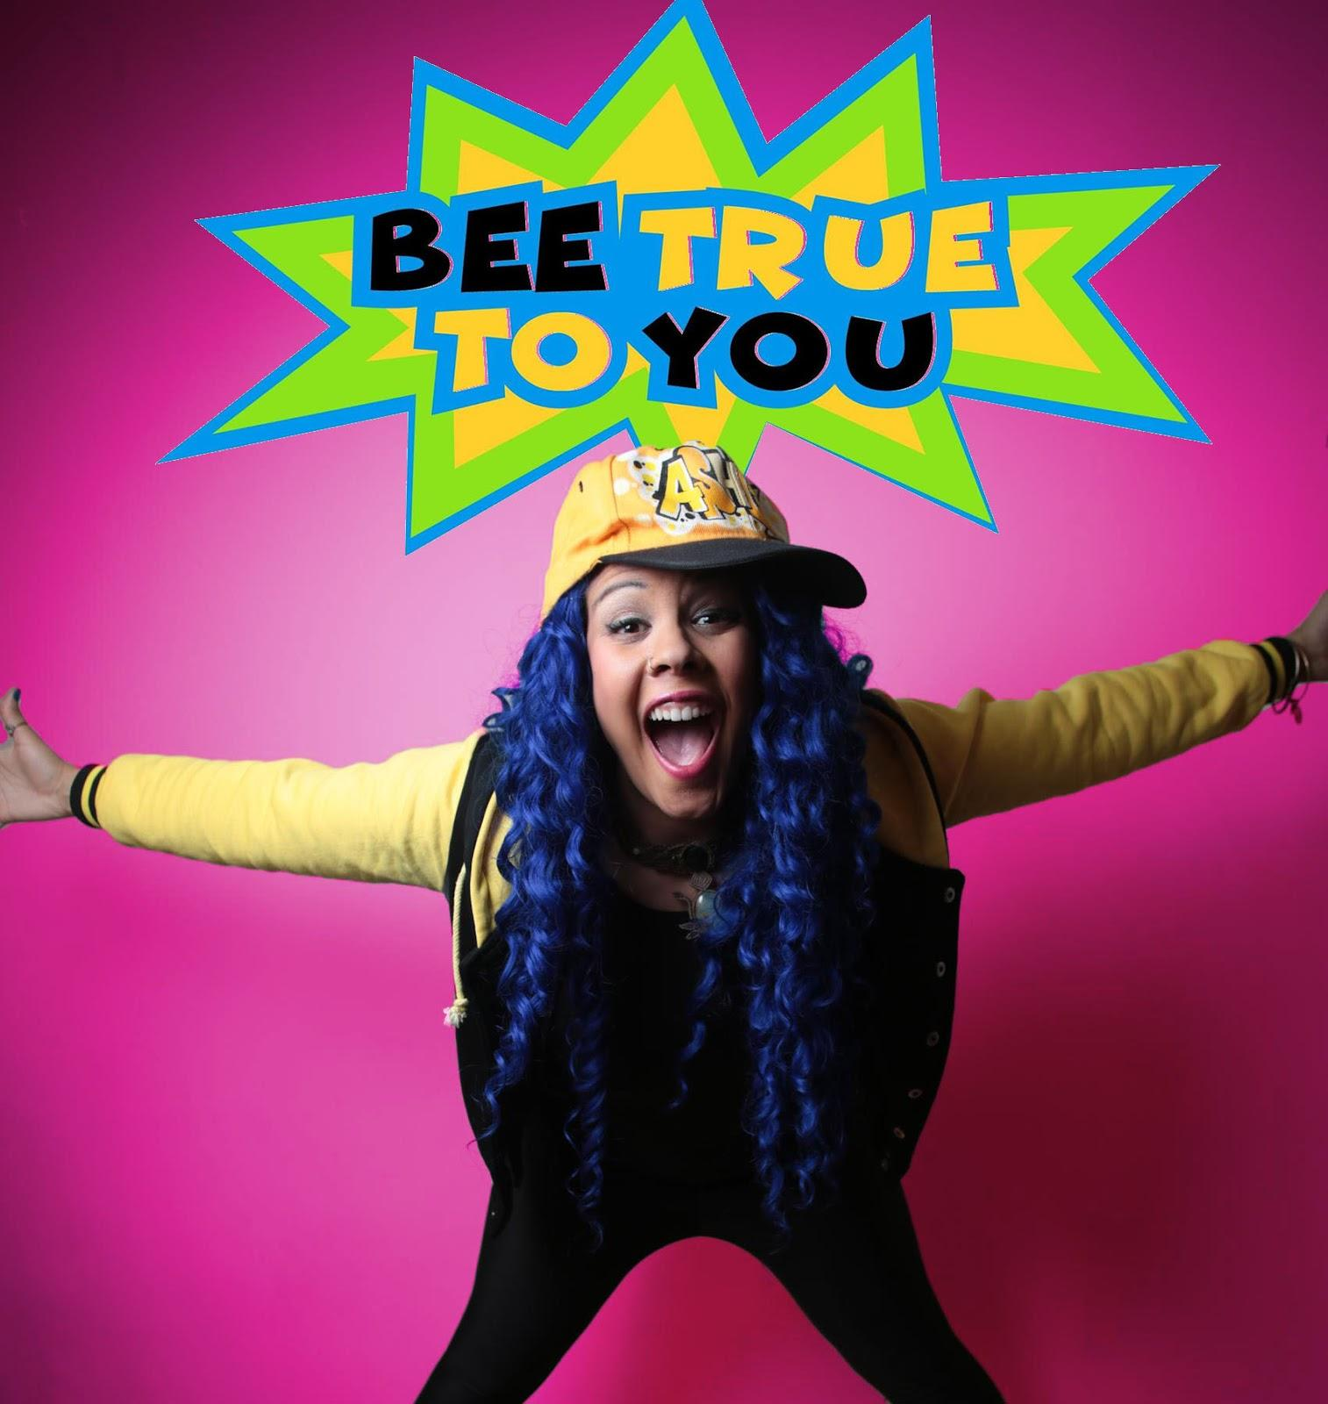

WATCH & SHARE: Bee True To You - Can’t Control Me
& 2018 BTTY LIVE! Promo Video
"It's the courage to believe, the fear to actually succeed, but most importantly it's about--- Being True To You" - TOBI

“Be True To You celebrates today's cultural diversity by empowering students with feelings of being an outsider, while delivering smart advice for coping. The performers, TOBI and BTTY the BEE, do all this though a show-stopping, pop musical that is relatable and down right cool! This program should be mandatory for all schools!"

- Dr. Sara Stranovsky, PhD, Culture and Performance Studies, World Arts and Cultures, UCLA

Today, New York City’s BEE TRUE TO YOU is thrilled to announce that their highly acclaimed interactive in-school assembly program, promoting confidence, acceptance and learning to believe in yourself, has implemented a new digital learning platform available to any child via ZOOM.

Bee True To You offers tiered subscription based pricing, drop in rates and an option to pay what you can, so that no child feels left behind! TOBI (singer, actor, dancer and humanitarian), the Founder/CEO of BTTY has earned positive recognition at several Tri-State area school systems in the past four years with her co-star BTTY the Bee. In 2016, Ashley Tobias aka TOBI was awarded the United Nations & Meaningful Worlds International Youth Peace Award for her humanitarian efforts within the youth community.

So, it only makes sense in the year 2020, that BTTY would take action by maintaining their program’s positive growth and developmental mission and extending their services virtually in homes across the world!

Bee True To You is a learning platform that brings theatre, dance parties, workshops and private music lessons right at a child’s doorstep. It’s a program designed to build long lasting memories, friendships, and skills that will be rooted within any participant's life forever. The virtual classes are held Monday through Friday and are tailored to fit the perfect summer camp setting! You will find programs such as A Rainy Day Recess, Music Lessons and Live Theatre for at-home entertainment.

“This is my daughter’s favorite part of the week. She is the shy daughter, but you’ve made her feel beyond comfortable, She doesn’t give half that much to her teachers on zoom. You are amazing!!!” said a parent who offered feedback for their hit series, the aforementioned, “A Rainy Day Recess.”

Bee True To You and it’s cultivated programs have integrated methods to help boost confidence within their classrooms and provide methods to tackling mental health concerns. Children’s mental health is critical to a child development and it’s BTTY’s mission to make sure they are equipped with the knowledge and skills to succeed in and outside of the classroom.

The fun doesn’t have to end after class, so be sure to check out their new weekly content on Youtube! When you subscribe, you’ll never miss out on BTTY’S Virtual Treehouse: Music Mondays, Wild Card Wednesdays, Story Time Fridays and their in school Podcast, Buzz Social. Not to mention, Bee True To You’s NEW video podcast that will premiere live on Facebook on Saturday, May 30th at 1pm Est.

Now you can even take the fun wherever you go with the Bee True To You full album, which was released in Fall 2019. The 16 tracked album is filled with empowerment, community and positive messages. The debut album includes its powerful track “Can’t Control Me”, where its accompanying music video involved 50 kids dancers!

“The skies the limit, when you are friends with a bee!”

She and her co-star, the Bee, met during their days of working together Off-Broadway in Julianne Moore’s Award Winning, Freckleface Strawberry - The Musical. The two Bee True To You characters teach children the values of friendship, kindness and discovering self identity through narrative and song. Through their own production they have revamped their setting and way of learning from traditional assemblies. BTTY has flipped “boring” lectures into a broadway-esque performance where children feel heard, approached and most importantly providing a safe space for being true to you. TOBI expressed within her personally written statement on bullying and BTTY’s mission during COVID 19, that “1 person can make a difference. That if you truly believe in yourself and the gifts you were given, THAT is the greatest strength a person can have.” Please read her full artist statement, HERE.

For more information on Bee True To You and what the program has to offer please view all necessary PDF and links provided within the Press Kit and visit their website: www.beetruetoyou.org.

Instagram: @bttythebee | @thatgirltobi
Facebook: https://www.facebook.com/Beetruetoyou/

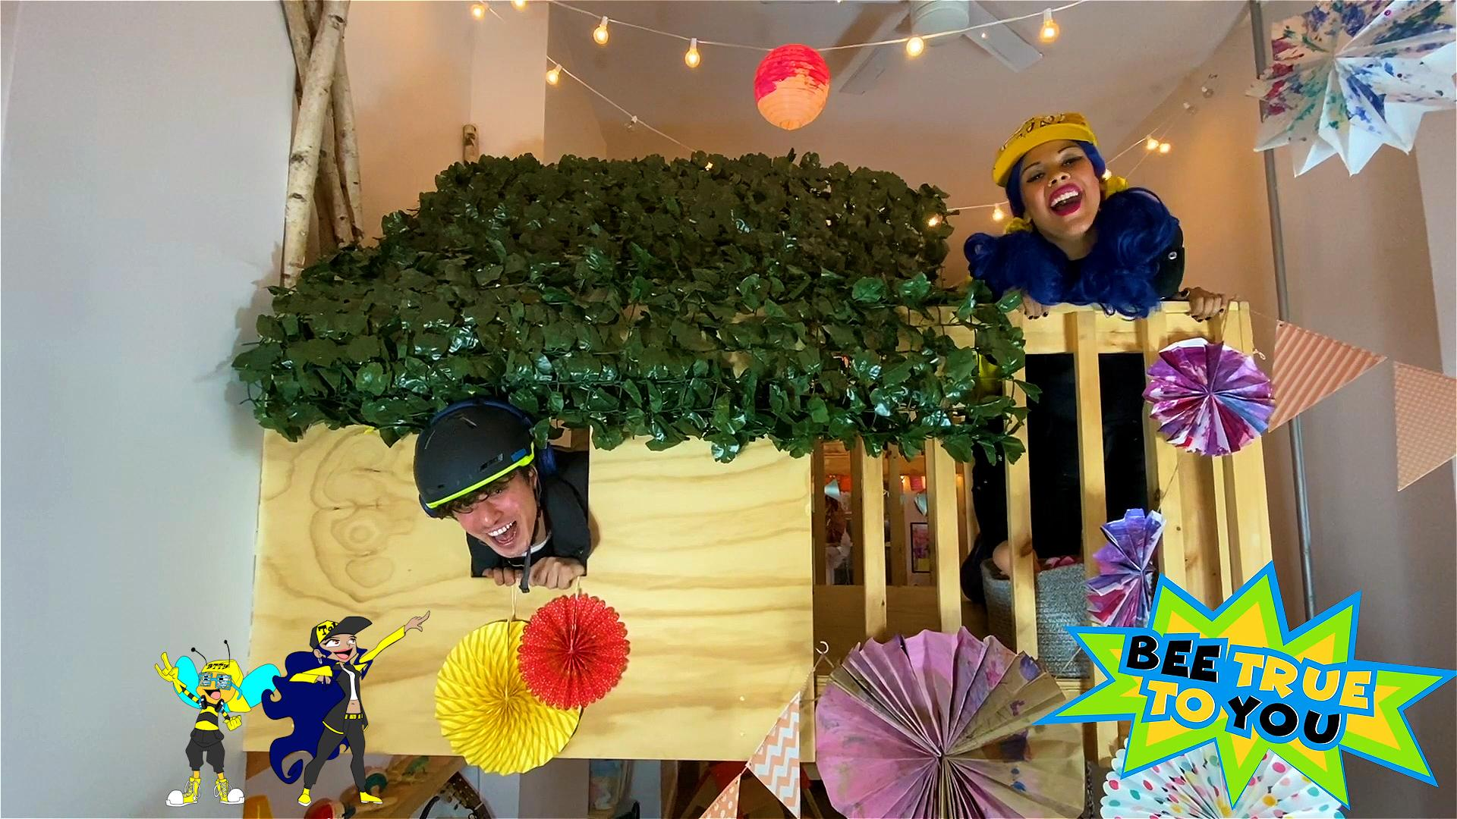

TOBI - Is a singer in the International headlining Rock Band Gogol Bordello, Broadway theatre professional, backup singer for multi platinum recording artists, youth speaker, alumni of Montclair State and Founder of Pop/Roc anti-bullying program Bee True To You. TOBI has toured Internationally in the cast of Green Day’s American Idiot, and has shared the stage with Green Day, The Hives, Danzig, Flogging Molly, Linkin Park, NIle Rogers and chic and more! She has provided backup vocals for Rachel Platten, Andy Grammer, and appeared on Kelly Rowland's TV Series “Chasing Destiny”. Her vocals can be heard on the soundtrack of Fox Search lights Motion Picture, Patti Cake$. When not touring the world, TOBI partners with Concerts in Motion, an organization bringing music to nursing homes, soup kitchens and hospitals in NYC. Other Past Credits Include: Off-broadway productions Freckleface Strawberry -The Music, the Ohmies, and Theatreworks’ Virtually Me - 1st National Tour.

